|  |  |  |
| --- | --- | --- |
| SCHOOL OF INFORMATION AND TECHNOLOGY | | |
| NAME: Padilla, Arvin | DATE PERFORMED:12/09/2024 |  |
| Section:IDC2 | DATE SUBMITTED:12/09/2024 |

# SYSADM1 – Managing Services in Linux

# Requirement:

* A virtual machine running Linux

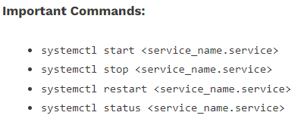

Complete this lab as follows:

Use the service –status-all command to list all active and inactive services.

List down active and inactive services in the table below. Provide five (5) services for each column.

|  |  |
| --- | --- |
| **Active** | **Inactive** |
|  |  |
|  |  |
|  |  |
|  |  |
|  |  |

SS: 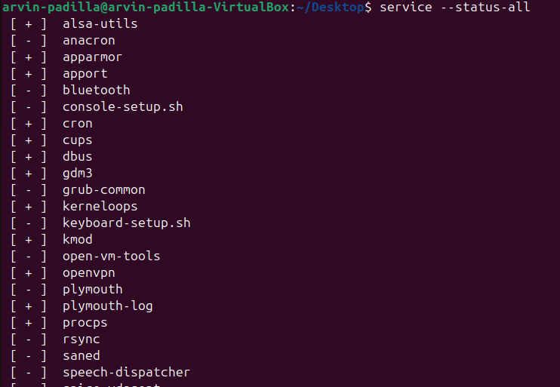syssudo starts

Start the Bluetooth service using the systemctl command.

Ex. sudo systemctl start httpd



Check the status of the Bluetooth service. What is its status?

The Bluetooth is still dead or inactive.

SS: 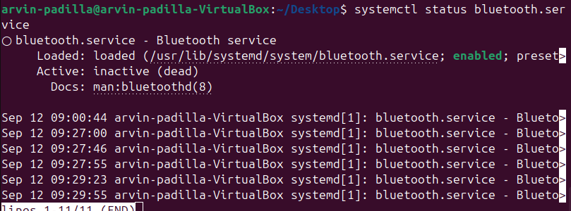

Check the status of the cups services. Since when was it running?

Since 34 mins ago.

SS: 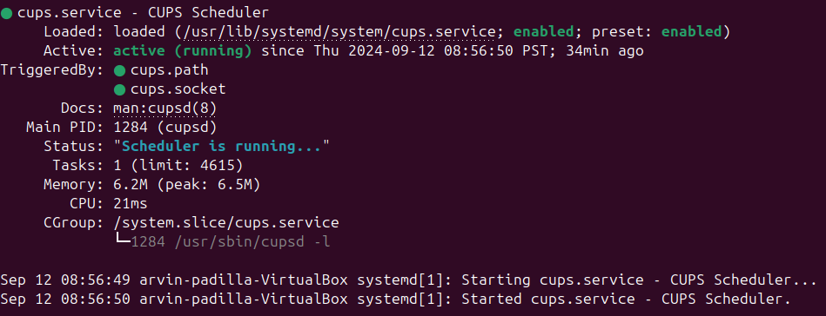

Stop cups services. 

Verify if the service was stopped.

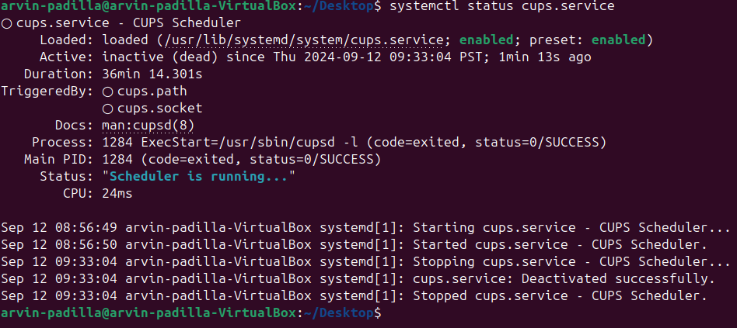

Restart the cups services



Verify if the service was restarted.

